Additions to The Illustrated History of the Larrakia Flag.
Insert paragraph below…….
The flag next appeared in the media in December when the Brinkin people who camped on the outskirts of Darwin beside the railway line, threatened to stop a goods train (see NT News 14 December 1971). Police who attended the scene reported that ‘a group of Aboriginals, which consisted of at least 37, men, women and children were gathered in the area.’ (National Archives, see Appendix 1). The report continues: ‘Sergeant Crellin remained in the vicinity of Day and the other police attended in the area of the main group of Aboriginals who lined up alongside the railway track and flew the Larrakia “flag”’ (Appendix 1). In a similar police report on the November 22nd Bagot Road ‘sit-down’ protest, it was noted that police had visited Bobby Secretary at his Kulaluk camp to execute a warrant. At the camp, according to the report, ‘Bobby Secretary also showed police the “Larrakia flag” which he stated had been made for them by the Maori lady Mrs Day’ (Appendix 1). The National Archives also reveal that the Director of the Department of Welfare, and Assistant Administrator, Mr Harry Giese, replied to an overseas query about the flag, ‘I think I should point out to you that it is extremely unlikely that the Aboriginal members of this [flag-raising] delegation were involved in the design of the flag.’ However, Giese’s reply attached a note with an incorrect description of the flag design (Appendix 1):

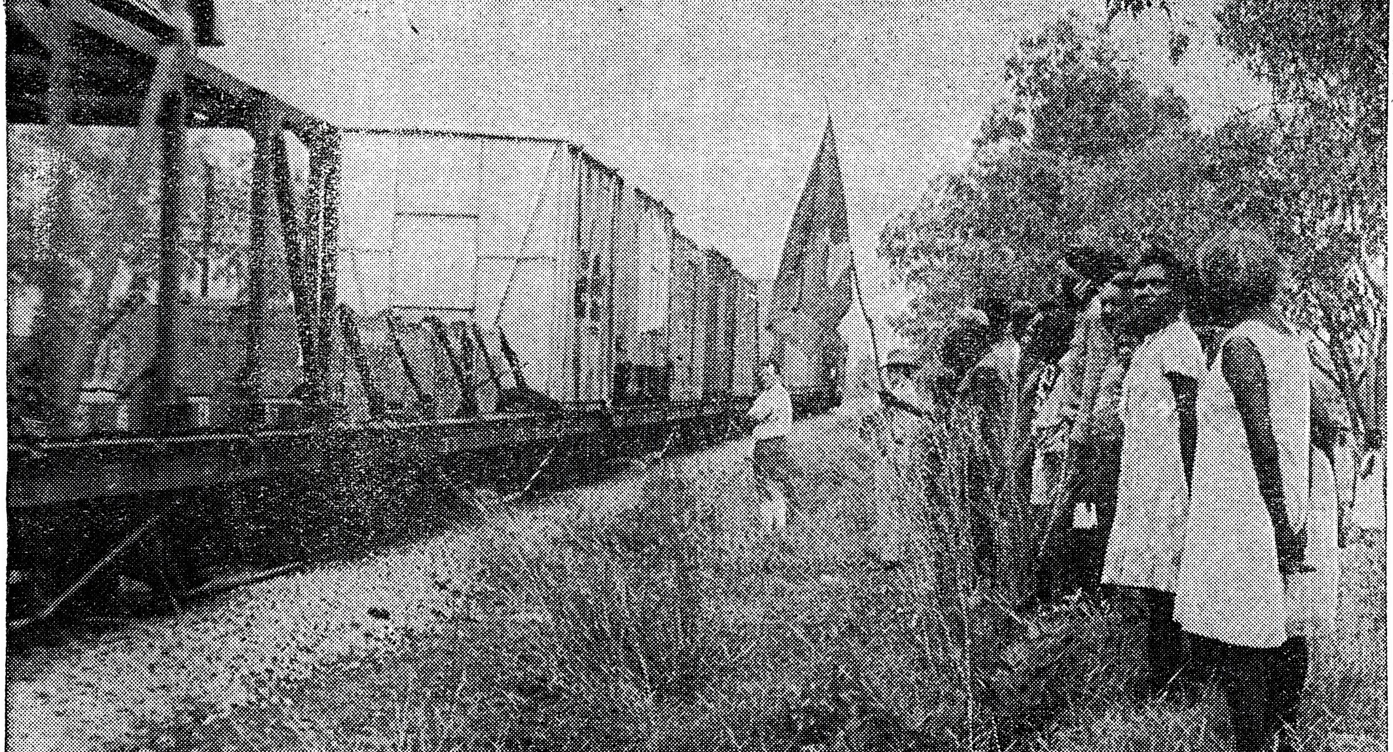
Plate 7 (Left): Police near the Berrimah crossroads guard Aboriginal protestors waiting to stop a Darwin bound goods train on December 13th, 1971. Bobby Secretary from Kulaluk is holding the Larrakia flag (centre). Photo from NT News, December 14, 1971.

